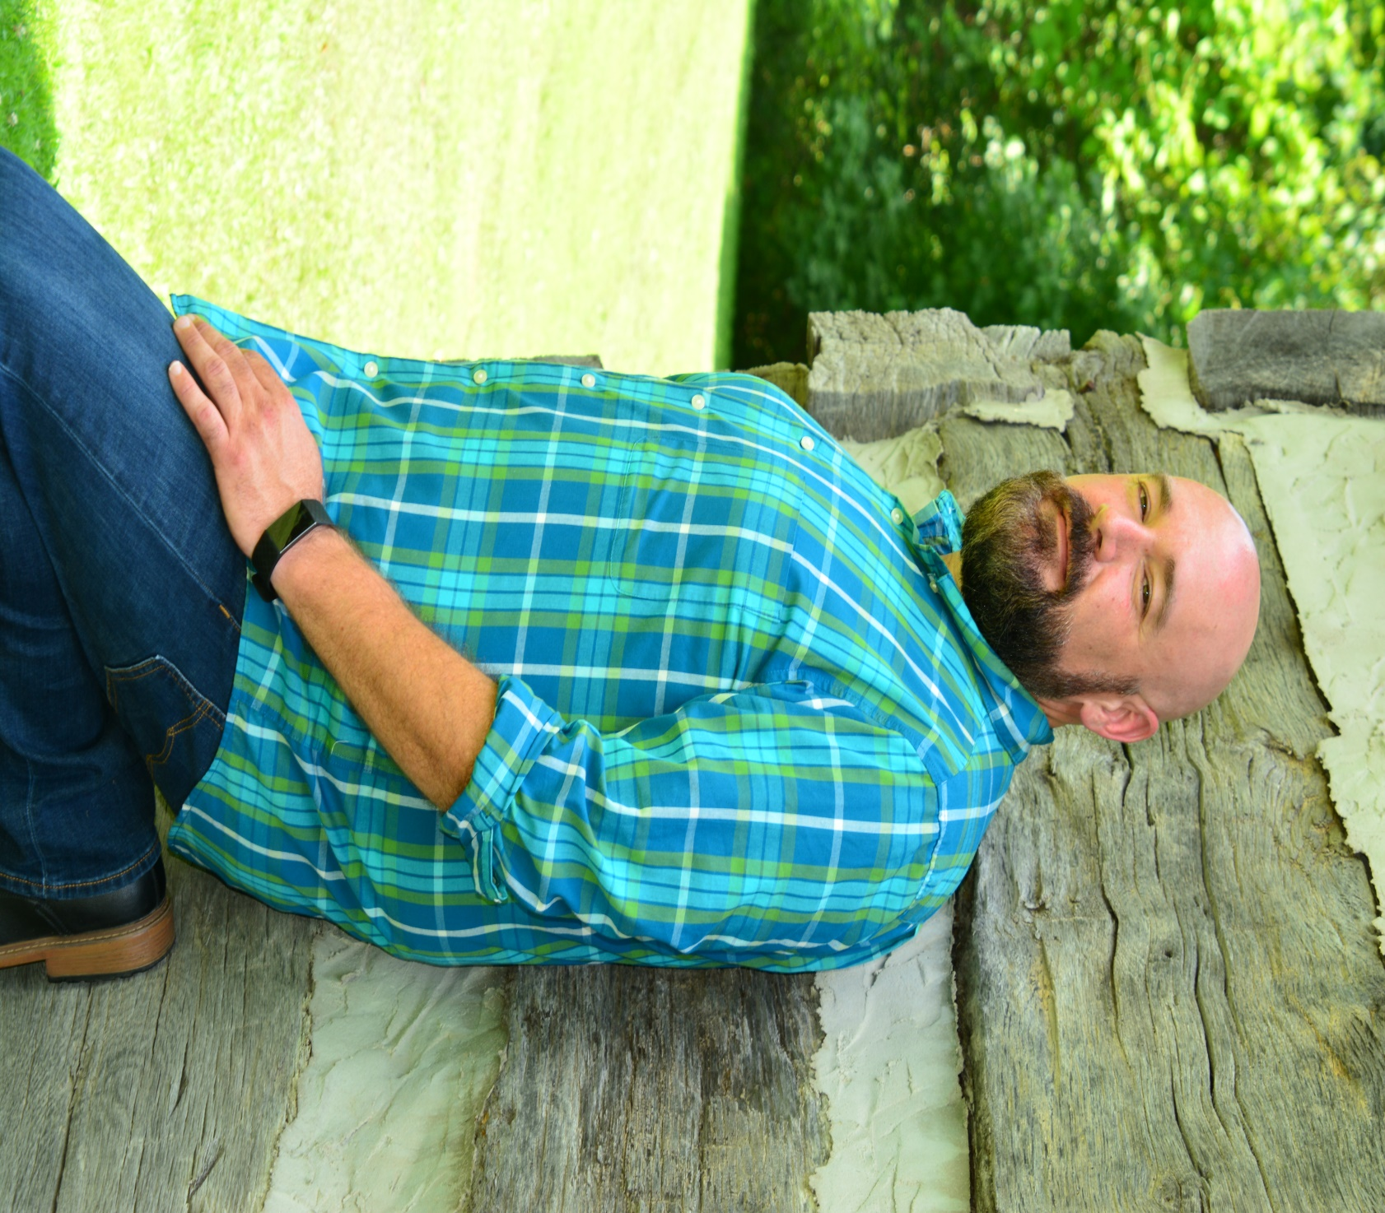

Jimmy Howson

IN CONCERT

PLACE:

TIME:

INFO: